Ms. Greenley  2nd Grade Teacher  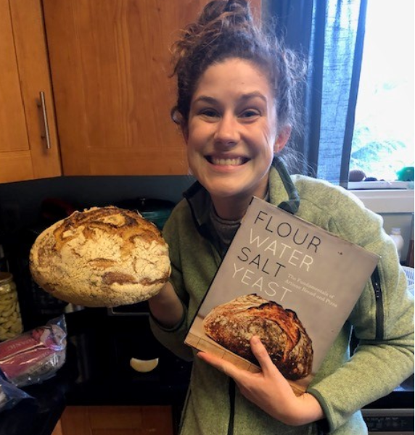  My baking means I’m reading lots of cookbooks and measuring lots of ingredients!  CONTACT  In Home Learning Website:  https://lakeridge.rentonschools.us/for-families/in-home-learning  Class Dojo: If you aren’t signed up yet check your email or texts for an invite!  Email: paige.greenley@rentonschools.us |  | Dear Families,  The past two weeks have been a whirlwind and a blur. I hope you are finding time to explore interests, get curious, and relax. This past week, I have been baking lots of bread, going for lots of walks with Ralph, and set a goal to read one non-fiction book for every fiction book I read. These two weeks apart have highlighted what is important to me, our Lakeridge community.  I have missed our classroom joy, curiosity, thoughtfulness, and learning, and I hope that we can stay connected during this time. Here are some ways we can!  - Visit Lakeridge’s website page and click the In-Home Learning Tab. It will be updated weekly with a message from me and some engaging activities and challenges to try. We plan to include some videos of us teachers showing some of our favorite addition and subtraction strategies! Also stay tuned for a Near 20 Championship with your classmates!  - Tell me about your day! Email me letters or questions. I’d love to hear about your day and support with any questions you have.  - Class Dojo! Feel free to message with any questions, ideas, or pictures of your learning.  I look forward to exploring virtual connection with you all and let’s stay and touch.  Sincerely,  Ms. Greenley  2nd Grade Teacher

