Number Line Addition

This week, we will be working on addition using a number line!

Choose ONE of the options below (Within 10, Within 20, or Within 100).
Look at the example given, and then complete the problems!

Then, I listed some different online games to help with basic fluency. Feel free to click the links on the last page to explore and have fun learning.

Option 1: Addition within 10 on a Number Line

Example:
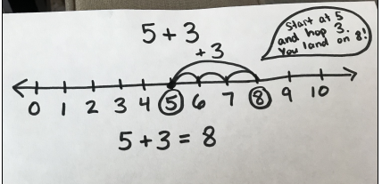

Use the number line to solve 6 + 2.
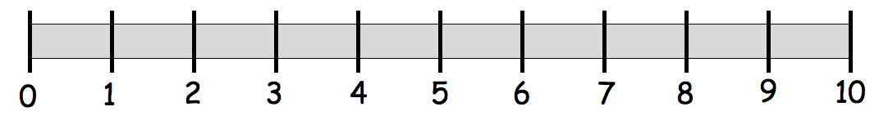

Use the number line to solve 1 + 7.

Use the number line to solve 3 + 4.

Show one way to make 10 using addition.

Option 2: Addition within 20 on a Number Line
Example:
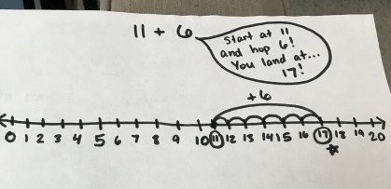

Use the number line to solve each addition problem.
13 + 2

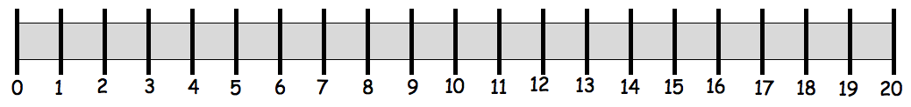
1 + 15

8 + 7

Rewrite one of your equations as a 10 + equation.

___ + ___ = 10 + ___

Option 3: Addition within 100 on a Number Line
Use an OPEN number line. Not every number is labeled, only what you’re landing on!

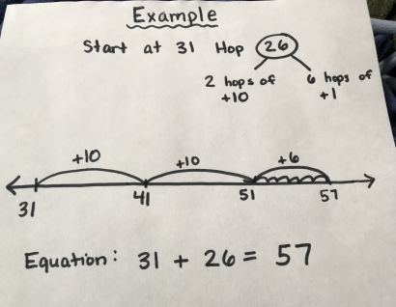
Start at 19 Hop 41

Write the equation:
Start at 33 Hop 27

Write the equation:

Start at 24 Hop 52

Write the equation:

Start at 42 Hop 25

Write the equation:

FINALLY….
The online games!
https://www.nctm.org/Classroom-Resources/Illuminations/Interactives/Ten-Frame/

https://www.mathplayground.com/ASB_AlienAddition.html

