Grade Math At Home, 3-5 grades!
Remember to show your thinking.
3/30-4/3

- Stamp Challenges (Source: mathlearningcenter.org)
- How many stamps do you see? What is the total cost of the stamps?
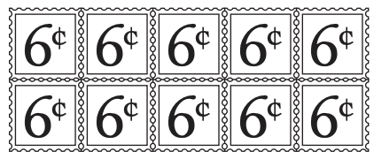

- Stevie has 4 cards with 8 stamps on each card. Cindy has 8 cards with 4 stamps on each card. Who has more stamps, Stevie or Cindy? How do you know?

- Challenge: Make up and solve your own stamp problems with stamps of a different cost.

2) Missing Digits
Fill in the blanks with digits to make the answer closer to 200 than 300. (Source: https://www.openmiddle.com/)

- Dressing Up
Mary likes to dress up her dogs. One wears a hat, one wears a coat, and one wears a scarf. Their names are Spot, Tag, and Barney. Tag loves to wear a scarf. Spot won’t wear the coat. Match each dog with what it wears. Explain your thinking.

- Pig Game
Materials: dice, pencil and paper.
Pig is a game for 2 or more players. Players take turns rolling the die as many times as they like. If a roll is a 2, 3, 4, 5, or 6, the player adds that many points to their score for the turn. A player may choose to end their turn at any time and “bank” their points. If a player rolls a 1, they lose all their unbanked points and their turn is over. Play to 50. (Source: mathforlove.org)

Alternative online option – Play the game 1-2 NIM: https://education.jlab.org/nim/

