Fifth Grade Engineering Challenge
Engineering is the process of designing solutions to problems, following criteria and constraints given.
Problem:
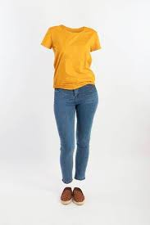
How can these clothes be standing up by themselves?

Your Challenge:
Create (engineer)a way to support your clothes in an upright position so that they look like you standing there.

Critera (Must Haves) | Constraints (Rules)
- Must include pants or skirt, shirt, shoes  - Must be in a standing position | - May not be supported by holding in any way. Must stand on its own.  - You can use anything you have around the house to keep the clothes upright and in position.

Want to share a picture of your solution with your classmates? Check the next page for ways to share.

- Google Classroom for the ENTIRE FIFTH GRADE (Slagle/Simpson)
Click here to go to Google Classroom and enter our code, 6j665gw
Once you are on our classroom page, then click on Classwork. You’ll see our Science Project for the week of 3/30/2020.

- Send your teacher a message showing the solution you’ve worked on. Use your parent/guardian’s Class Dojo app. You can add pictures if you want.

- Send an email to margaret.simpson@rentonschools.us or Nicole.slagle@rentonschools.us and show the solution you’ve worked on this week.

