Task 1:
- Watch “Cheddar K-12 Explains: The Tiny Compound That Makes Soap a Coronavirus Killer” on Discovery Education (accessible through your child’s Renton School District Login).
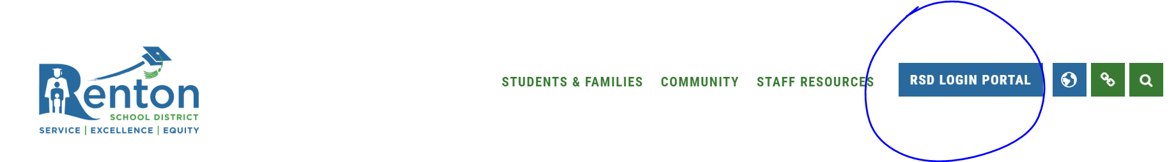
- Read the article below called “Stopping the Spread of Germs”.

- Create a poster explaining why it is important to wash your hands.

- *Optional: take a picture of your poster and send it to your teacher through email, ClassDojo, or save on your Google Drive.

Science & Math

Stopping the Spread of Germs
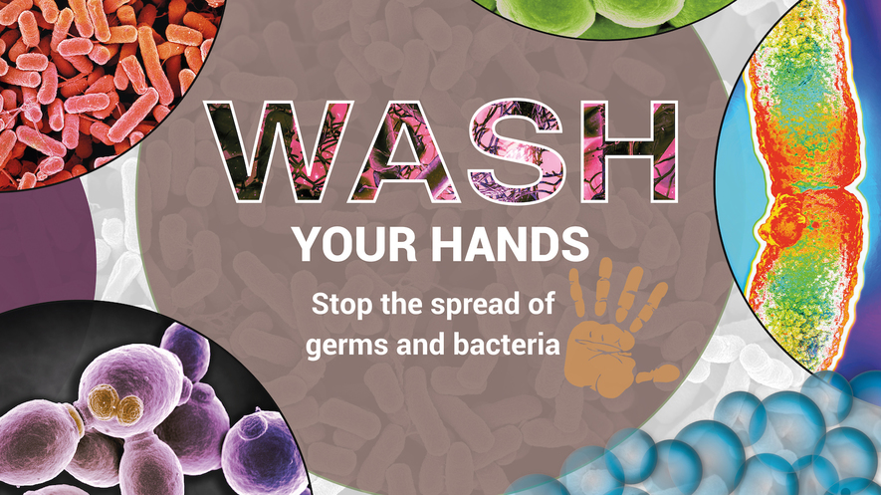Image 1. Washing your hands is an easy way to stop germs from spreading. It helps prevent other people from getting sick. Photo: Nano Creative/Science Source
By National Geographic Society, adapted by Newsela staff
Published:01/28/2020
Word Count:915
Recommended for:Upper Elementary School - High School
Text Level:8
A contagion is a way in which a disease can be transmitted from person to person. It can start out with something as simple as a cough. If a person passes too close and inhales infected droplets, the disease can spread to the population at large, in no time. It can create an outbreak, a sudden increase in the number of sick people in a place. Fortunately, there are ways to prevent and manage such catastrophes.
The simplest measures are known as nonpharmaceutical interventions or NPIs. These are methods that prevent illnesses from spreading without using medicines or vaccines.
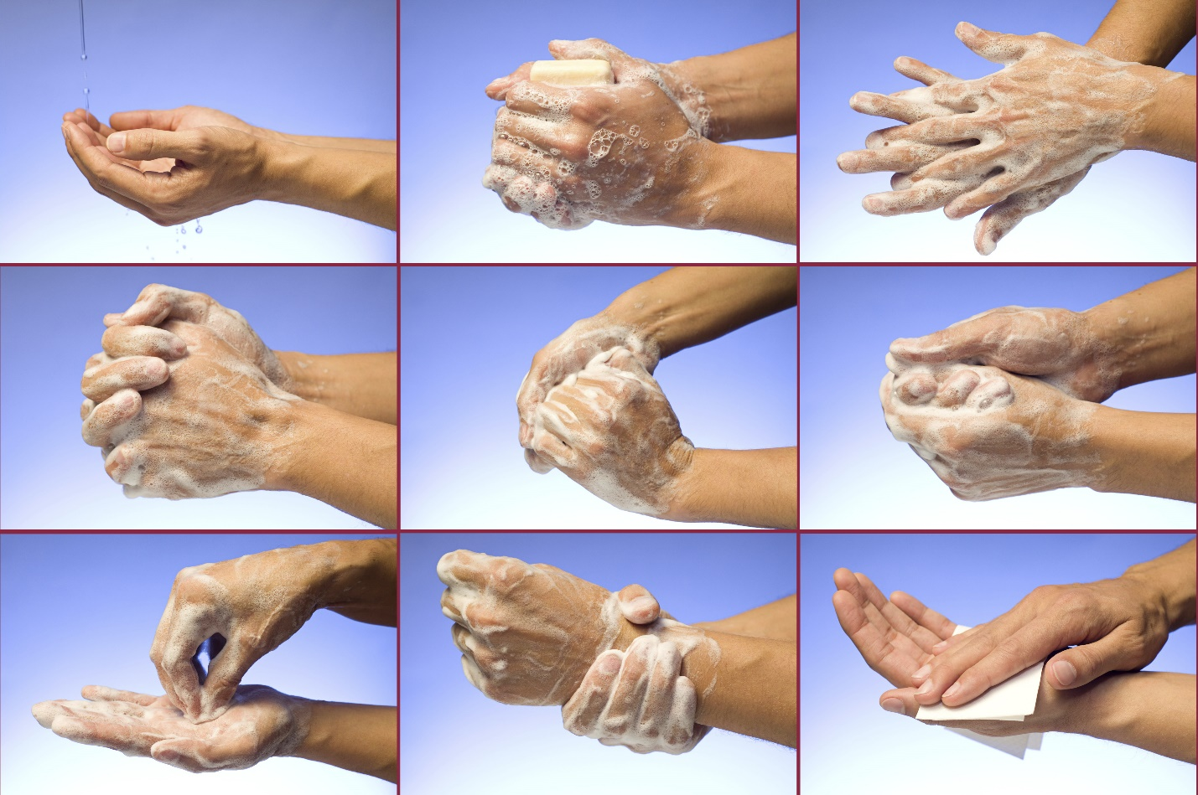Image 2. The steps of washing your hands. This method makes sure that the most forgotten places on your hands are also clean. Photo: Laurent Belmonte/Science Source
You are probably already familiar with this type of intervention, especially if you have had a cold or flu. These methods are effective against pathogens, or disease-causing germs, that can be spread through person-to-person contact. These include things that include staying home when you are sick so that you don't come into contact with other people. Others are washing your hands so they're clean when you touch common things such as doorknobs. Sneezing or coughing into a tissue or your elbow prevents saliva from spreading through the air.

Preventing Further Infections
NPIs can be used with other prevention measures, like vaccines, to strengthen an individual's chances of avoiding infection. NPIs are simple and inexpensive, and might sometimes be the only prevention tool that individuals can use.
Prevention methods do not always work. If someone is infected with an illness or disease, they should seek treatment as soon as possible so that they can be healed quickly and not pass it on to others.
Once health practitioners identify cases of disease, they can take steps to prevent further infections. These steps vary and depend on the pathogen. A common method is through quarantine, which involves separating an individual who might have come into contact with the infectious disease, from other people. An infectious disease is one that is passed on easily from person to person.

Quarantine And Isolation
The United States has quarantine stations at ports and border crossings across the country that are staffed by the Centers for Disease Control and Prevention (CDC). The CDC might quarantine any traveler suspected of carrying an infectious disease or they may opt to send them to a hospital.
Isolation is another method to prevent the spread of disease. During isolation, a sick individual is separated from those who are not sick. This is in contrast to a quarantine, which separates an individual who might have been exposed to an illness, but is not showing symptoms of being sick. Similar to quarantines, the CDC has the authority to isolate an individual suspected of carrying a contagious disease that would harm the public.
The exact procedures of both isolation and quarantine depend on how severe the disease is. Chickenpox, for example, is highly contagious and can be passed through skin contact or through the air. When infected, children are instructed to not attend school so they do not infect their classmates. However, because the disease is relatively mild, those who are infected can be isolated at home. On the other hand, more serious and deadly diseases, such as Ebola or measles, might require help from the government. In such cases, it is illegal to break an isolation or quarantine order. Additionally, severely ill individuals are likely to be isolated in a hospital setting.
Authorities might also choose to close public spaces to prevent the spread of disease. For example, schools can shut down if there is an increase in influenza, or flu, cases. While the CDC provides instruction for more severe global outbreaks, it does not officially determine if schools should close for the flu. Instead, it is up to the school. However, recent evidence suggests that school closures can help to limit exposure to the contagion and prevent the spread of disease.

Foodborne Illnesses Can Involve Recalls
A different approach is needed if the contagion is foodborne, or spread through food. It can be recalled if it is labeled wrong or if there is a physical substance such as plastic that makes it impure. Or it can be recalled to prevent the spread of pathogens carried by food, such as the bacteria salmonella. During a recall, food has to be pulled off shelves in grocery stores to prevent more people from getting sick from tainted food. People who have already purchased recalled food should not eat it and throw it away.
The U.S. Food and Drug Administration (FDA) is responsible for regulating most food products. Exceptions include meat, poultry and some egg products, which are regulated by the U.S. Department of Agriculture's Food Safety Inspection Service (FSIS). When there is a foodborne illness, the CDC launches an investigation, and if the threat could seriously endanger the public, the FDA begins to warn the public through the media.
Although meat that is not cooked well often gets a bad reputation for being a source of bacteria, leafy greens such as lettuce and spinach are more often responsible for foodborne illnesses. The 2011 Food Safety Modernization Act improved sanitation standards. Modern advances in technology make it easier for experts to track outbreaks and identify the source.
From the large-scale policies and procedures of government agencies to individuals washing their hands, we all have a role to play in preventing disease outbreaks.

