Mr. Zuray  ILC Kindergarten Teacher  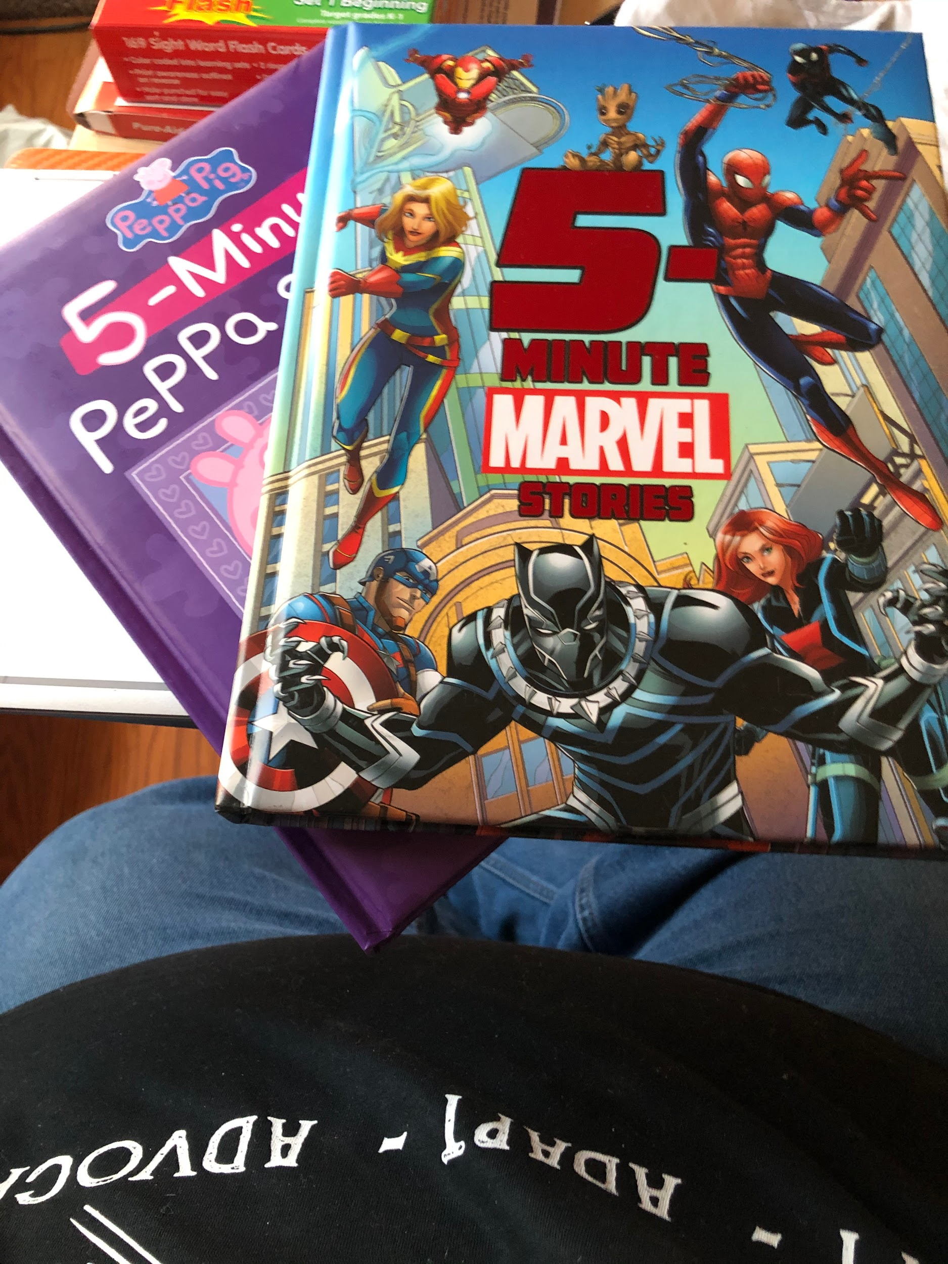  I got a couple new books I can’t wait to read with you.  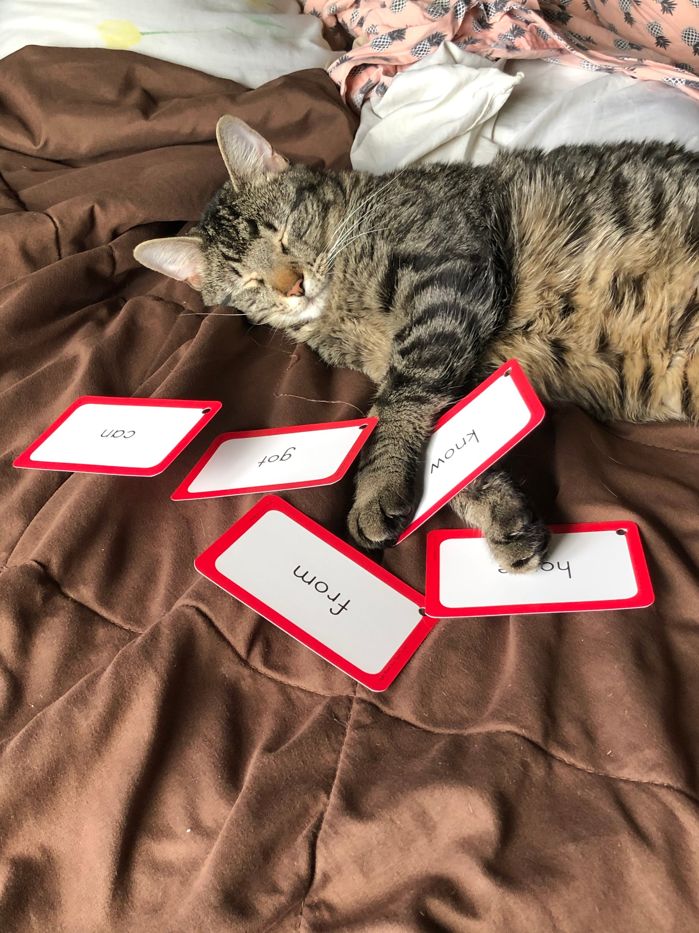  My cat Gallileo didn’t want to learn sight words.  CONTACT  In Home Learning Website:  https://lakeridge.rentonschools.us/for-families/in-home-learning  Class Dojo: If you have not yet joined, please check your e-mail for an invitation from me!  Email: brandon.zuray@rentonschools.us |  | Dear Students and Families,  I hope everyone is doing well and staying safe. I miss seeing all of your lovely faces, and look forward to the day we will be back together. I have been keeping busy reading and spending time with my family. I look forward to keeping up with you through the school website and creating projects for you to do at home.  - Visit Lakeridge’s website page and click the in-Home Learning Tab. This will give you access to the updates from me, and the projects that I put together for you.  - I would love to hear from you through email. Send me pictures of things you are doing, and notes. I am always checking my email, and will respond as soon as I can.  - Class Dojo! Most of you are not added on Class Dojo, but I would love to see you on there. It is a pretty cool app, so I encourage you to download it. I can send you all an invite by either email or phone number. Email me if you are interested.  - I would like you to utilize the activities that are in the kindergarten folder as much as you can. I will be uploading some activities that you can use as well.  I look forward to exploring virtual connection with you all and let’s stay and touch.  Sincerely,  Mr. Zuray

