Monday: What is a bar graph? 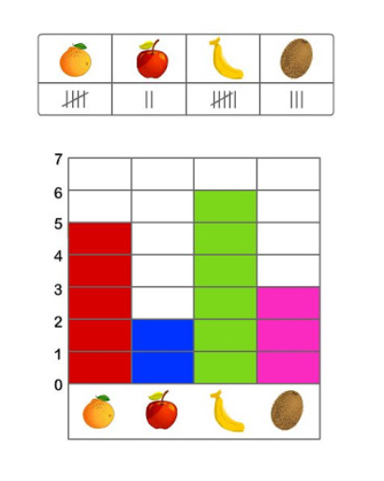  Create a bar graph for items around your house. | Tuesday: Problem of the Day:  Create a bar graph using either set of data below.  Video Game Data  Kids voted for which game they enjoy the most.  Data Set 1 Data Set 2  Roblox - 23 votes Fortnite- 37 votes Minecraft-29 votes Roblox- 147 votes Fortnite-63 votes Minecraft- 158 votes
Wednesday: Answer the questions that go with the bar graph you made on Tuesday.  Looking at your bar graph, how many fewer voted for ______ than ______?  Looking at you bar graph, how many voted in all? | Thursday:  - What if your family voted, how would that change the data?  - What’s the difference in votes between data set 1 and data set 2?
Friday: Celebrate, bar graph expert!
Bonus: Using the bar graph you created on Monday for items around your house, create questions to go along with it. Then have someone solve.

