Read Aloud
“The Hug”
- Listen to the book “The Hug” written by Sharon Fear, found at this link. You might recognize the reader https://youtu.be/uf2ZVIQaVxg

- Complete the phonics activity below with the -ug word family:
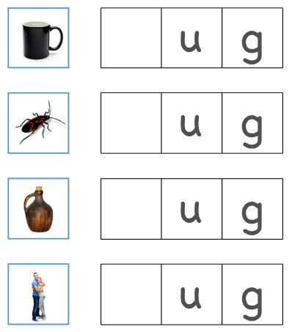

THEN…..

- Choose from the following options for your book response.
OPTION A – Draw a picture of how the problem was solved in the story.

Option B: Write a sentence describing Moosling OR write a sentence about what the problem was in the story.

Sentence Frame:
Moosling is _____________ because ___________________.
Your Sentence: _____________________________________________________________________________
_____________________________________________________________________________
_____________________________________________________________________________

Sentence Frame:
The problem in the story was ____________________.
Your Sentence:
____________________________________________________________________________
____________________________________________________________________________
____________________________________________________________________________

Option C: Write a paragraph to summarize the story. Make sure to include a sentence about the problem, the main events in the story, and how the problem was solved.
_____________________________________________________________
_____________________________________________________________
_____________________________________________________________
_____________________________________________________________
_____________________________________________________________
_____________________________________________________________
_____________________________________________________________
_____________________________________________________________
_____________________________________________________________
_____________________________________________________________
_____________________________________________________________
_____________________________________________________________
_____________________________________________________________
_____________________________________________________________

