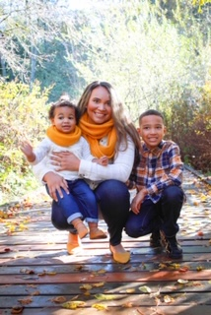  Ms. Kirklin  CONTACT  In Home Learning Website:  https://lakeridge.rentonschools.us/for-families/in-home-learning  Email:  amanda.kirklin@rentonschools.us |  | Hello Families!  The last few weeks, I have been busy preparing lessons for you all. There has been a lot of new learning for me such as virtual teaching! I hope you all check out the KT talk show that Ms. Trice and I had the opportunity to put together. It was so much of fun! I hope you enjoy the activities from KT talks, as much as we did creating it.  I am continuing to spend my time teaching and playing with my own kids. We enjoy going for walks outside and playing soccer in our yard.  It was great to chat with some families! Please keep in touch via email. Also, if you have time can you respond to the following:  - What is going well with our “In-Home Learning” supports?  - What isn’t going so well?  - Is there anything that I can help with to make this process easier?  Please don’t forget:  - I have aligned activities to where your learner is at. Therefore, please note the grade at the top of the page to ensure the activity is appropriate for your learner.  - There will be a weekly social emotional activity that all learners can do.  I miss you all!  Amanda Kirklin

