Reading and Writing (4-5)

Monday:  - Picture Walk and skim the text.  - Words to know: Enclosure, Habitat, Captivity.  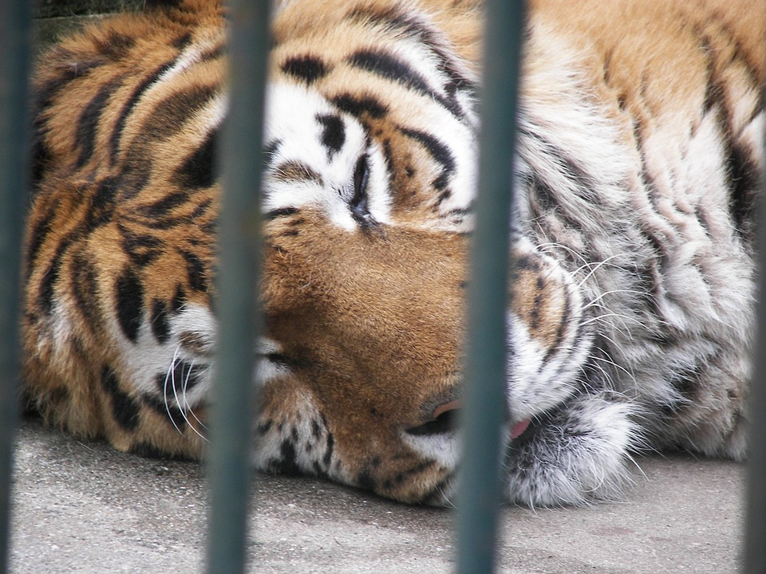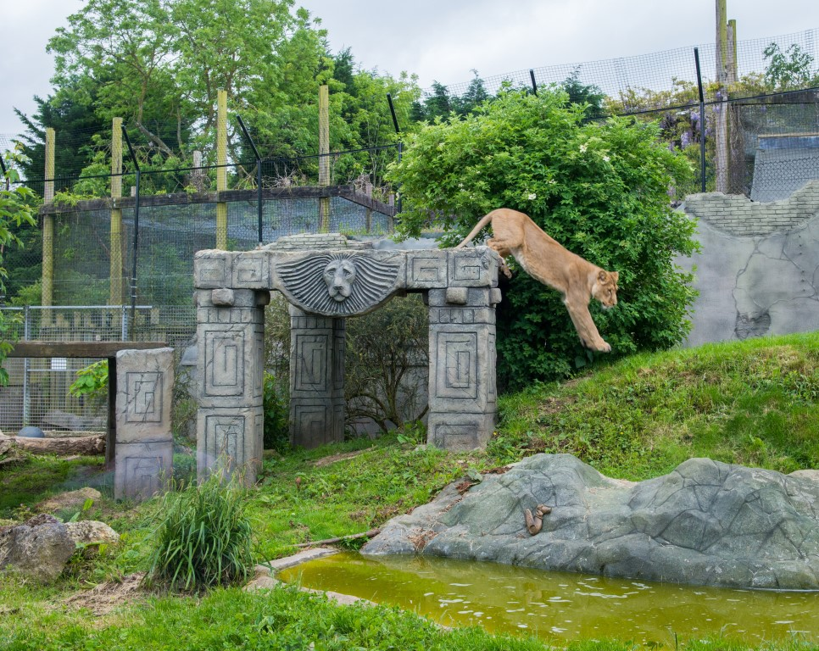  - Draw a picture that illustrates each word.  - Pre Reading Discussion: What are your opinions about zoos? | Tuesday:  Read the Article: Should This Lion Cub Belong in a Zoo?  - Stop and jot as you read. Notice your wonderings, your reactions, and your questions.
Wednesday:  So what do you think?  Is it okay to keep animals in zoos? Should they stay in their natural habitats? Write your opinion and use some evidence from the reading.  Don’t forget to start each sentence with a capital letter and end each sentence with an end mark. | Thursday:  - Draw a picture of what an ideal day at the zoo looks like for you and explain it.  - Look at the chart: why do you think the main reason zoos exsist? 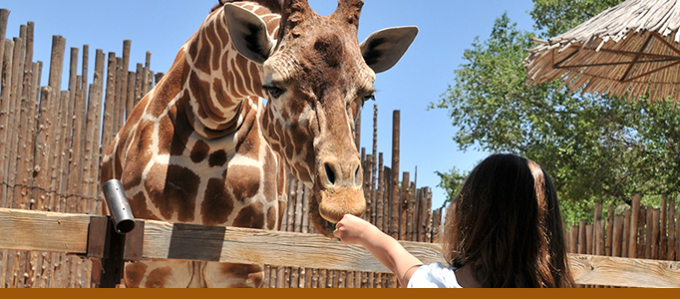
Friday:  Do you know the history of zoos? Research the history and then do a quick write-up on the history or a sketch of the history of zoos. | Bonus Question:  Thinking about the pre-reading question on Monday: What are your opinions about zoos.  After reading the article, did your opinion change? Why or why not?

Tuesday Reading: 