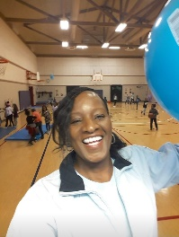
Debra Augurson
Lakeridge Physical Education Specialist
Email: Debra.walkeraugurson@rentonschools.us

Hello Lakeridge families,
I hope all is well with each one of you during our time away from school. I have been staying busy doing odd jobs around the house. I exercise and walk a lot usually in the mornings and after dinner. I’ve also been cooking a lot of good meals making sure I eat a balanced diet.
I’m constantly thinking about you all and looking forward to physical education, hearing all your stories about how you stayed active and some of your healthy meals. If needed you can email or message me for more activities, I can’t wait to see you all!
Here are links for continuing your PE Learning at home:
Kids workout 1 Beginners
The 5 Fabulous Food Groups SciShow Kids

Current Activities for week of 3/30/20
Do these 3 times a week.
Lesson 1
Warm up and Exercises
- Yoga Poses hold each pose 20 seconds then repeat. 5 Minutes
- Students will do exercises for different parts of the body. 20 Minutes
- Mindful Mediation 5 Minutes

Kinder/1st Grade
Lakeridge Yoga Warm Up
Yoga enhances your flexibility, strength, coordination, and body awareness. Hold each position for 20 seconds repeat.
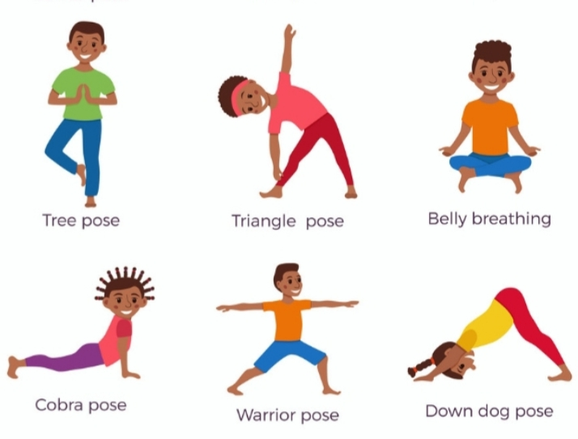

Do all 10 exercises for 1 minute.
Count how many, do it 2 times see if you can improve your score.
We exercise to increase strength in muscles and bones and even improve concentration in school.

Cool Down with Mindful Mediation.
Slow down your breathing, just relax think about a relaxing place 3-5 minutes.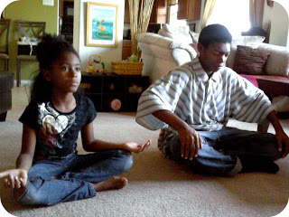
This Photo by Unknown Author is licensed under CC BY-NC-ND

