Math: Week 1 In Home Learning

Spend 30 minutes per day (Monday-Thursday) on Math. Friday is an optional day of math, where you are encouraged to create your own Which One Doesn’t Belong. Share a photo with your teacher so she can post it on Class Dojo for others to see!

Activity Type | Monday | Tuesday | Wednesday | Thursday | Friday
Reasoning | WWDB | WWDB | WWDB | WWDB | WWDB
Games | Near 20 | Near Doubles Bump | Near 20 | Place Value Double Compare | Choice
- WWDB = Which One Doesn’t Belong (see below)
  - Find more examples at http://wodb.ca/index.html
- Math Games
  - Near 20
  - Place Value Compare/Double Compare
  - Near Doubles Bump
  - Coin War
  - Time Match

Try to solve these extra problems using a number line!
36 + 49 = | 94 - 27 =
58 - 19 = | 46 + 25 =
87 + 23 = | 73 - 54 =

Math: Week 1 In Home Learning

Which One Doesn’t Belong: This is a math reasoning activity where students will support their thinking with evidence. Four images are put together with the goal of finding one image that doesn't belong. There is no one right answer, any of the images can be justified to belong or not belong.

Here is an example:
Image A doesn’t belong because it is the only one to say “Speed Limit.” or Image A doesn’t belong because it is the only one to have a 5 in the ones place.

Image B doesn’t belong because it is the only image with a 3-digit number.

Image C doesn’t belong because it says the speed in km/h (kilometers/hour).

Image D doesn’t belong because it is the only one with blue sky behind it.

All answers are valid--there is no one right answer. The key is to justify your answer with evidence (reasons).
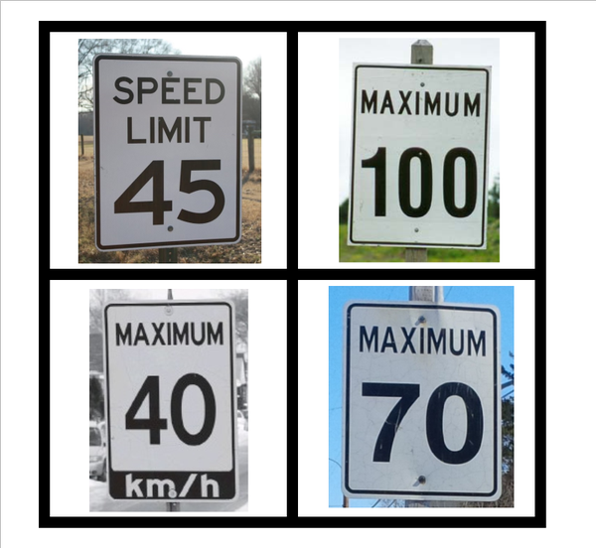
Monday
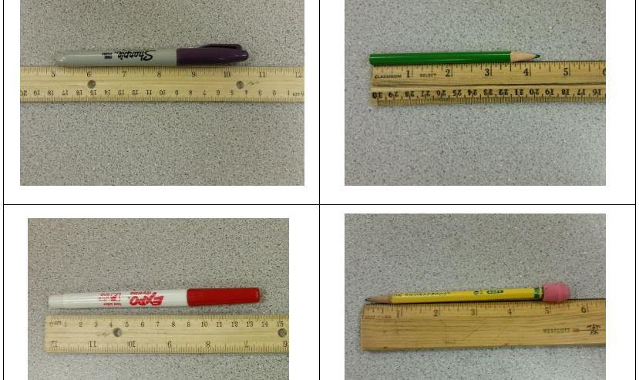

I think picture ___ doesn’t belong because ___.

Tuesday

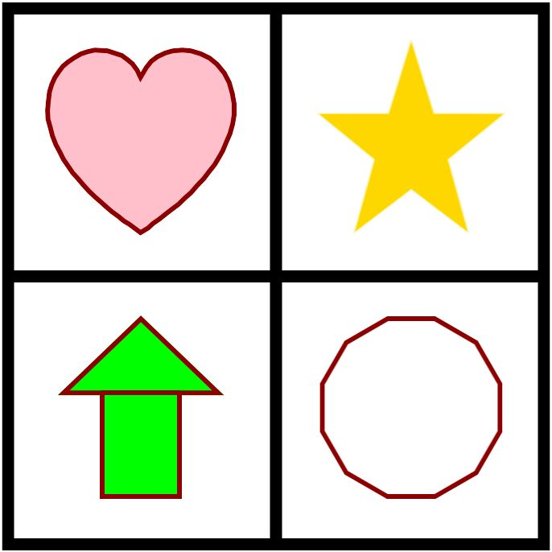

I think ___ doesn’t belong because ___.
Wednesday
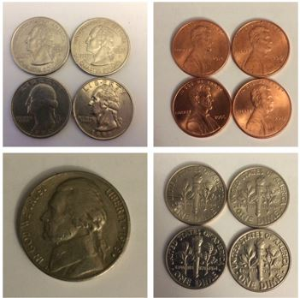
I think ___ doesn’t belong because ___.

Thursday

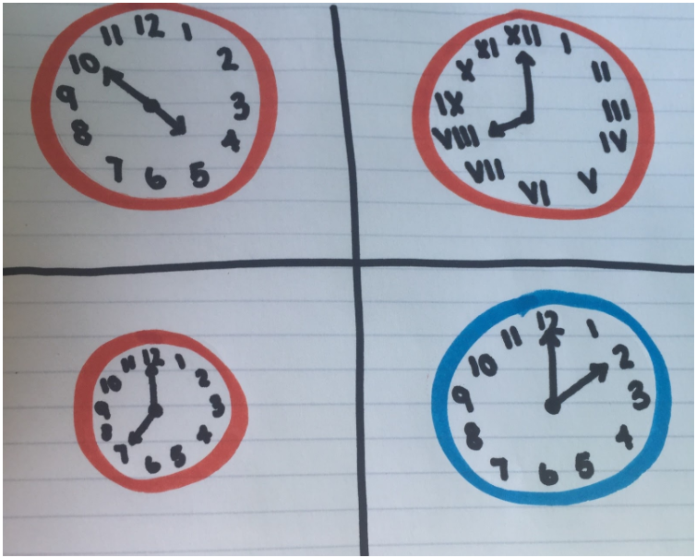
In my opinion, clock ___ doesn’t belong because ___.

Friday: Make your own and try it on your family! You could draw pictures or place objects and take a picture of your Which One Doesn’t Belong.

Image A doesn't belong because _________________________________________

______________________________________________________________________

Image B doesn't belong because _________________________________________

______________________________________________________________________

Image C doesn't belong because _________________________________________

______________________________________________________________________

Image D doesn't belong because _________________________________________

______________________________________________________________________

