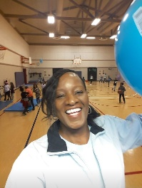
Debra Augurson
Lakeridge Physical Education Specialist
Email: Debra.walkeraugurson@rentonschools.us

Hello Lakeridge families,
I hope all is well with each one of you during our time away from school. I have been staying busy doing odd jobs around the house. I exercise and walk a lot usually in the mornings and after dinner. I’ve also been cooking a lot of good meals making sure I eat a balanced diet.
I’m constantly thinking about you all and looking forward to physical education, hearing all your stories about how you stayed active and some of your healthy meals. If needed you can email or message me for more activities, I can’t wait to see you all!
Here are a links for continuing your PE Learning at home:
Kids workout 1 Beginners
The 5 Fabulous Food Groups SciShow Kids

Current Activities for week of 3/30/20-4/3/20
Lesson 1
Warm up and Exercises
- Yoga Poses hold each pose 20 seconds then repeat. 5 Minutes
- Students will do exercises for different parts of the body. 20 Minutes
- Mindful Mediation 5 Minutes

2nd/3rd Grade
Lakeridge Yoga Warm Up
Yoga enhances your flexibility, strength, coordination, and body awareness. Hold each position for 20 seconds and repeat.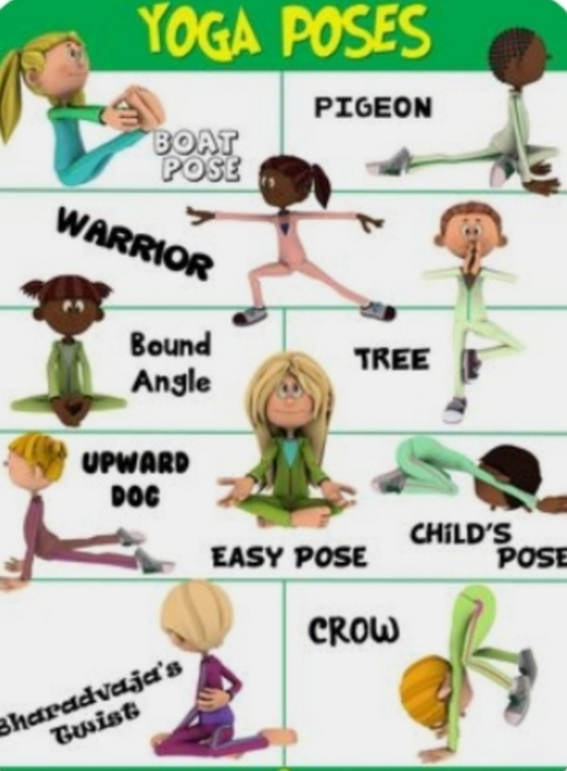

Ready Set Go!
Do these exercises 2 times a day!
We exercise to increase strength in our muscles and bones and even improve concentration at school.
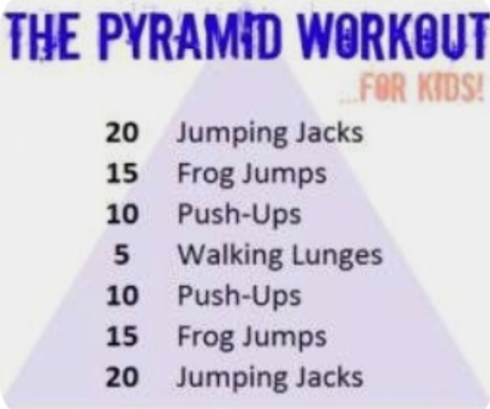

Cool Down with Mindful Mediation
Slow down your breathing and just relax think about a relaxing place 3-5 minutes.

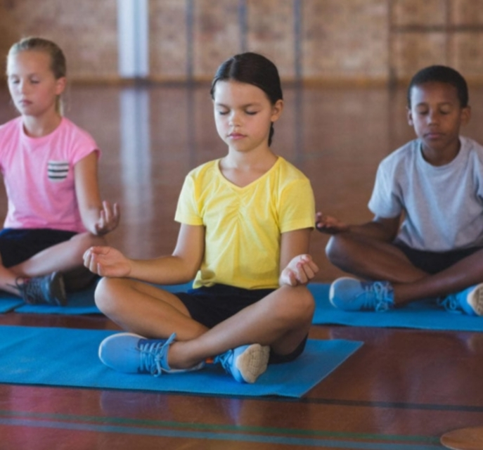
Review The 5 Food Groups
This Photo by Unknown Author is licensed under CC BY-NC-ND

