Literacy: Week 1 In Home Learning
Writing your own Fairy Tale Adaptations: Cinderella
Your teachers miss your fabulous writing and we want to see what amazing things you can do with the Cinderella story! Check out the week plan below for an idea of how you could plan your work across a week. Have another idea for a fairy tale you want to write? Go for it!

Monday | Tuesday | Wednesday | Thursday | BONUS Activities!
-Watch a read aloud of Yeh-Shen by Gina Sabella  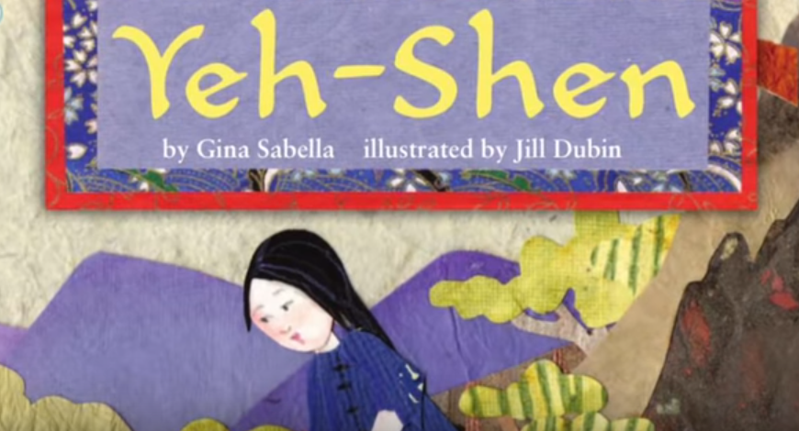  https://www.youtube.com/watch?v=WTsCk5fJYpo  -Fill in the graphic organizer with the story elements  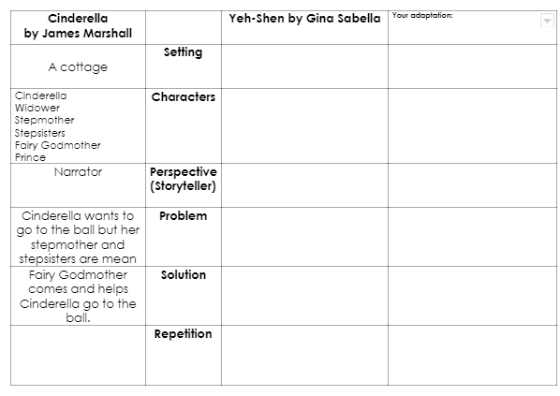  EXTRA! Watch a read aloud of the James Marshall Cinderella that we read at school:  https://www.youtube.com/watch?v=UqIzdiPvSqg | Plan your own adaptation of the Cinderella story using the graphic organizer | WRITE, WRITE, WRITE! Write your Cinderella adaptation across many pages!  !!!  *You can write on any paper you have - plain paper, loose leaf paper, notebook paper. You can use a pencil, pen, marker or crayon! | Revise and edit your Cinderella adaptation  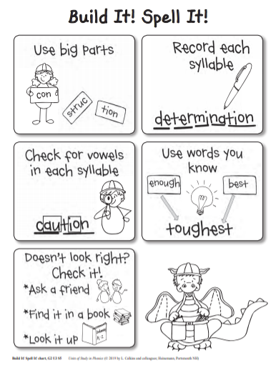 | -Type or take pictures of your story and send it to Ms. Greenley, Ms. Hardy, or Ms. Smith.  -Read more versions of Cinderella on MyOn  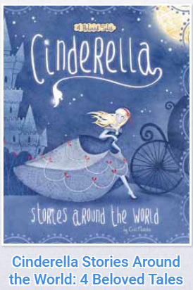  ***Don’t forget to read books you love EVERYDAY for 30 minutes twice a day! You can find lots of books on MyOn and use eBooks and audiobooks from the King County Library too!***

Cinderella  by James Marshall |  | Yeh-Shen by Gina Sabella | Your adaptation:
A cottage | Setting
Cinderella  Widower  Stepmother  Stepsisters  Fairy Godmother  Prince | Characters
Narrator | Perspective (Storyteller)
Cinderella wants to go to the ball but her stepmother and stepsisters are mean | Problem
Fairy Godmother comes and helps Cinderella go to the ball. | Solution
 | Repetition
TIPS!
- Don’t have a printer for the graphic organizer? You can DRAW your own like this:
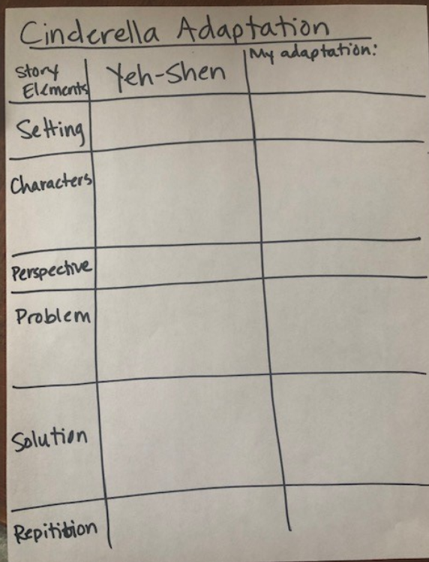
- Have to share a computer/tablet? The read aloud videos are appropriate for younger siblings too!

- Having trouble making your story come to life? Remember that 2nd grade stories have TALK, ACTION, and FEELINGS! It can help to ask a family member to act out the story with you!

- Not sure how to fill out the graphic organizer or plan your story? Send a Class Dojo message or email to your teacher! We are happy to help!

